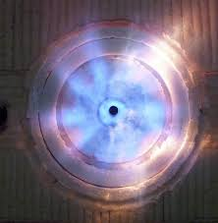
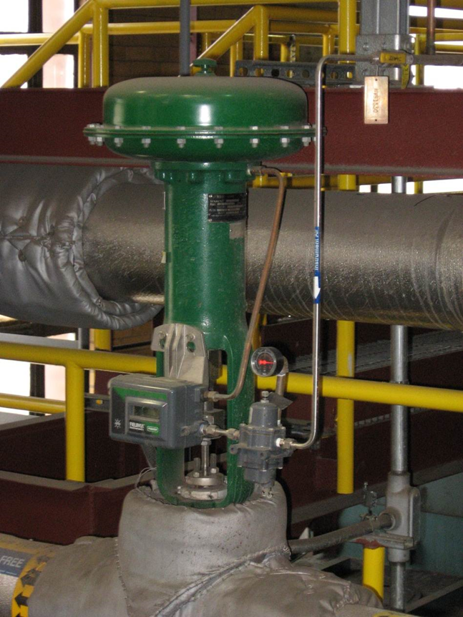
Presented By: Thermal System Training, LLC
Course Dates: October 5 – 9, 2026 / 8:00 AM – 4:00 PM
Cost $ 2,350 per person
* New Class Location is in Christiansburg Virginia at:
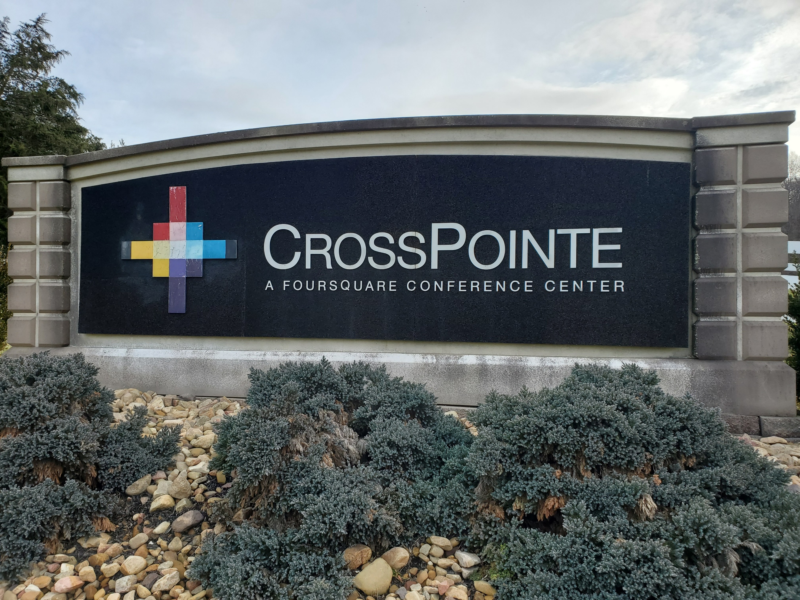
610 Peppers Ferry Road, Christiansburg Virginia 24073

Reservations: 855-530-1049
For more information and to register visit us at:
Thermalsystemtraining.com
CrossPointe Conference Center
936 Life Drive #45
Christiansburg, Virginia 24073
Light breakfast, beverages, and lunch will be provided each daily.
Nearby Lodging includes:
Holiday Inn, Christiansburg 540-381-8100
Hampton Inn, Christiansburg 540-381-5874
SureStay Hotel, Christiansburg 540-381-0500

For more information and to register visit us at:
Thermalsystemtraining.com
Topics covered includes:
- Stationary engineering principles
- Boilers
- Steam and water fitting and accessories
- Boiler operation & maintenance
- Steam turbines
- Steam turbine operations & maintenance
- Water treatment
- Electrical principles
- Steam management
- Computer-integrated control systems
www.thermalsystemtraining.com
Advanced Boiler Operator Training & Certification

T
S
T
Thermal
System Training LLC

