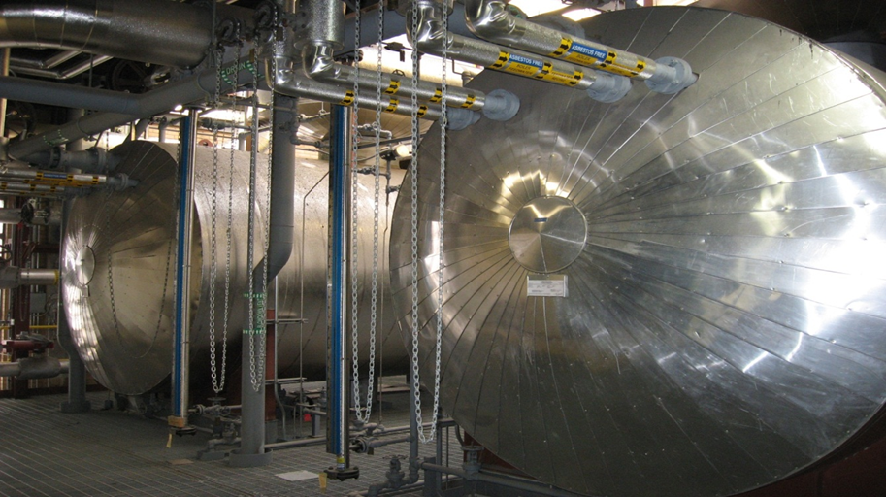
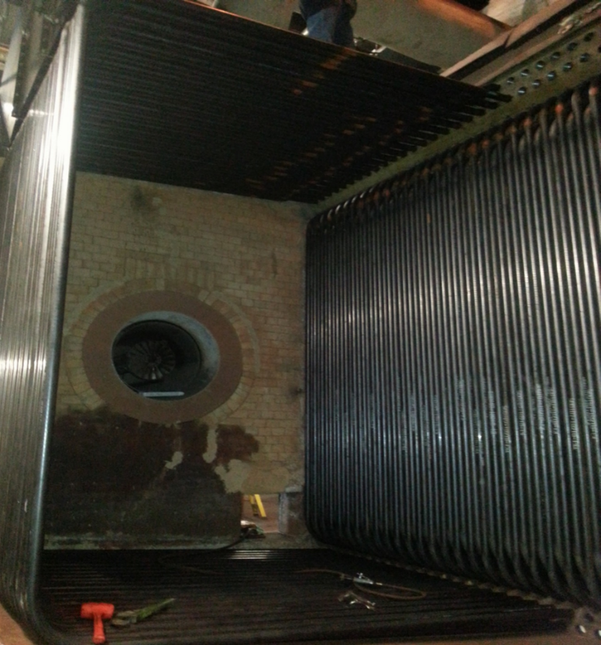
Presented By: Thermal System Training, LLC
Course Dates: June 22 – 26, 2026 / 8:00 AM – 4:00 PM
Cost $ 2,250 per person
* New Class Location is in Christiansburg Virginia at:
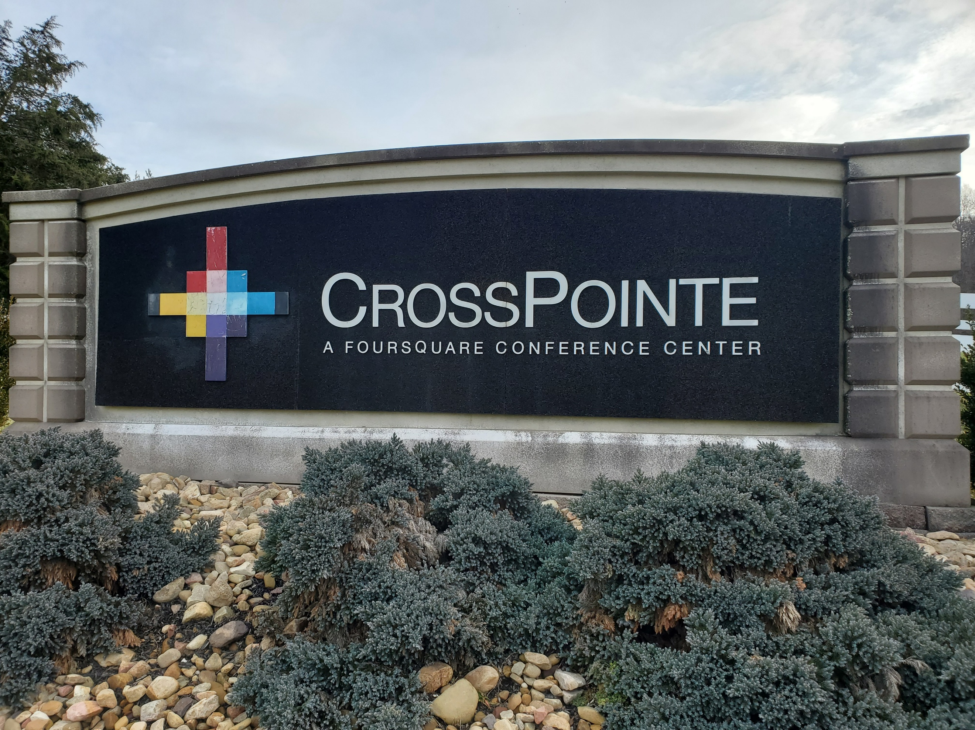
610 Peppers Ferry Road, Christiansburg Virginia 24073

Reservations: 855-530-1049
For more information and to register visit us at:
Thermalsystemtraining.com
Crosspointe Conference Center
936 Life Drive #45
Christiansburg, Virginia 24073
Light breakfast, beverages, and lunch will be provided daily.
Nearby Lodging includes:
Holiday Inn, Christiansburg 540-381-8100
Hampton Inn, Christiansburg 540-381-5874
SureStay Hotel, Christiansburg 540-381-0500

For more information and to register visit us at:
Thermalsystemtraining.com

Topics covered includes:
- Steam boilers
- Boiler systems
- Steam boiler fittings
- Steam systems
- Feedwater systems
- Feedwater systems
- Water treatments
- Combustion equipment
- Fuels and combustion
- Combustion and boiler controls
- Draft systems
- Instrumentation and control systems
- Steam boiler operation
www.thermalsystemtraining.com
Basic Boiler Operator Training & Certification

T
S
T
Thermal
System Training LLC

