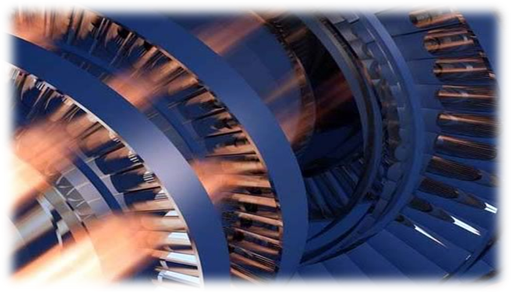
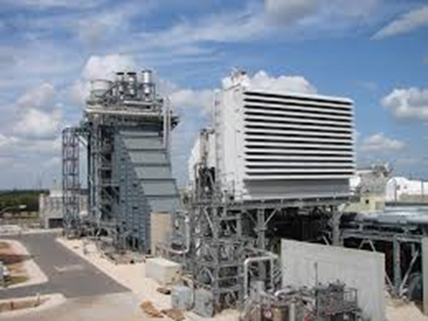
Presented By: Thermal System Training, LLC
Course Dates: July 20 – 24, 2026 / 8:00 AM – 4:00 PM
Cost $ 2,375 per person
* New Class Location is in Christiansburg Virginia at:
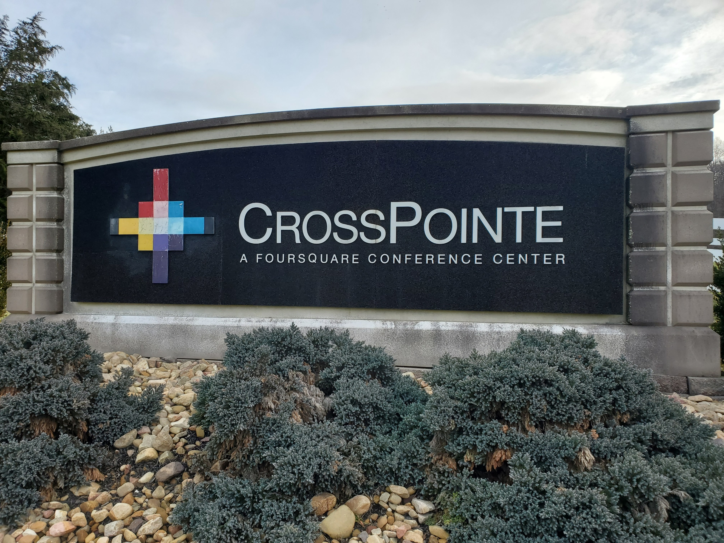
610 Peppers Ferry Road, Christiansburg Virginia 24073

Reservations: 855-530-1049
For more information and to register visit us at:
Thermalsystemtraining.com
CrossPointe Conference Center
936 Life Drive #45
Christiansburg, Virginia 24073
Light breakfast, beverages, and lunch will be provided daily.
Nearby Lodging includes:
Holiday Inn, Christiansburg 540-381-8100
Hampton Inn, Christiansburg 540-381-5874
SureStay Hotel, Christiansburg 540-381-0500

For more information and to register visit us at:
Thermalsystemtraining.com

Topics covered includes:
- Combine cycle basics
- Cycle electrical basics
- Combined cycle thermodynamics
- Gas turbine engines
- Types of gas turbines
- Combined cycle concepts
- Boiler basics
- Water treatment basics
- Heat recovery steam generators
- Steam turbines
- Combined cycle plant operations
- Electrical generators
- Environmental considerations
www.thermalsystemtraining.com
Basic Combined Cycle Training Course

T
S
T
Thermal
System Training LLC

