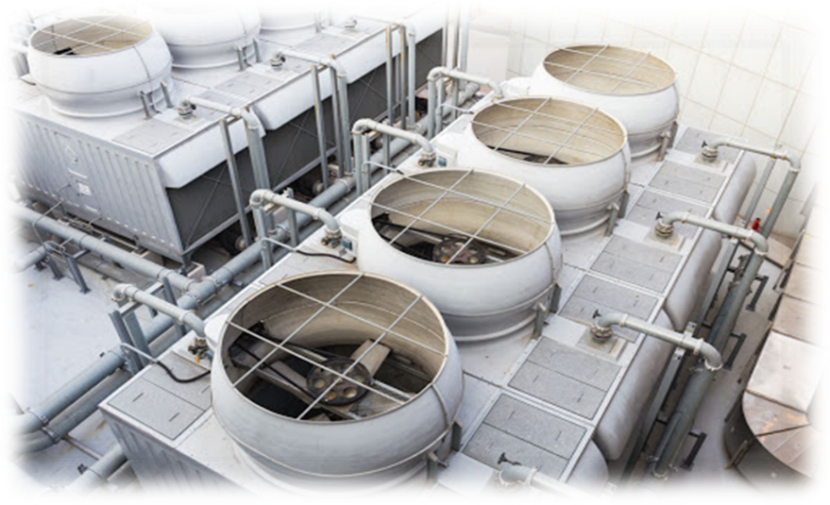
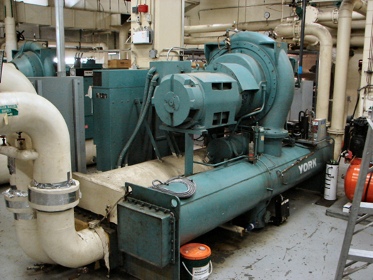
Presented By: Thermal System Training, LLC
Course Dates: March 9 – 13, 2026 / 8:00 AM – 4:00 PM
Cost $ 2,250 per person
* New Class Location is in Christiansburg Virginia at:
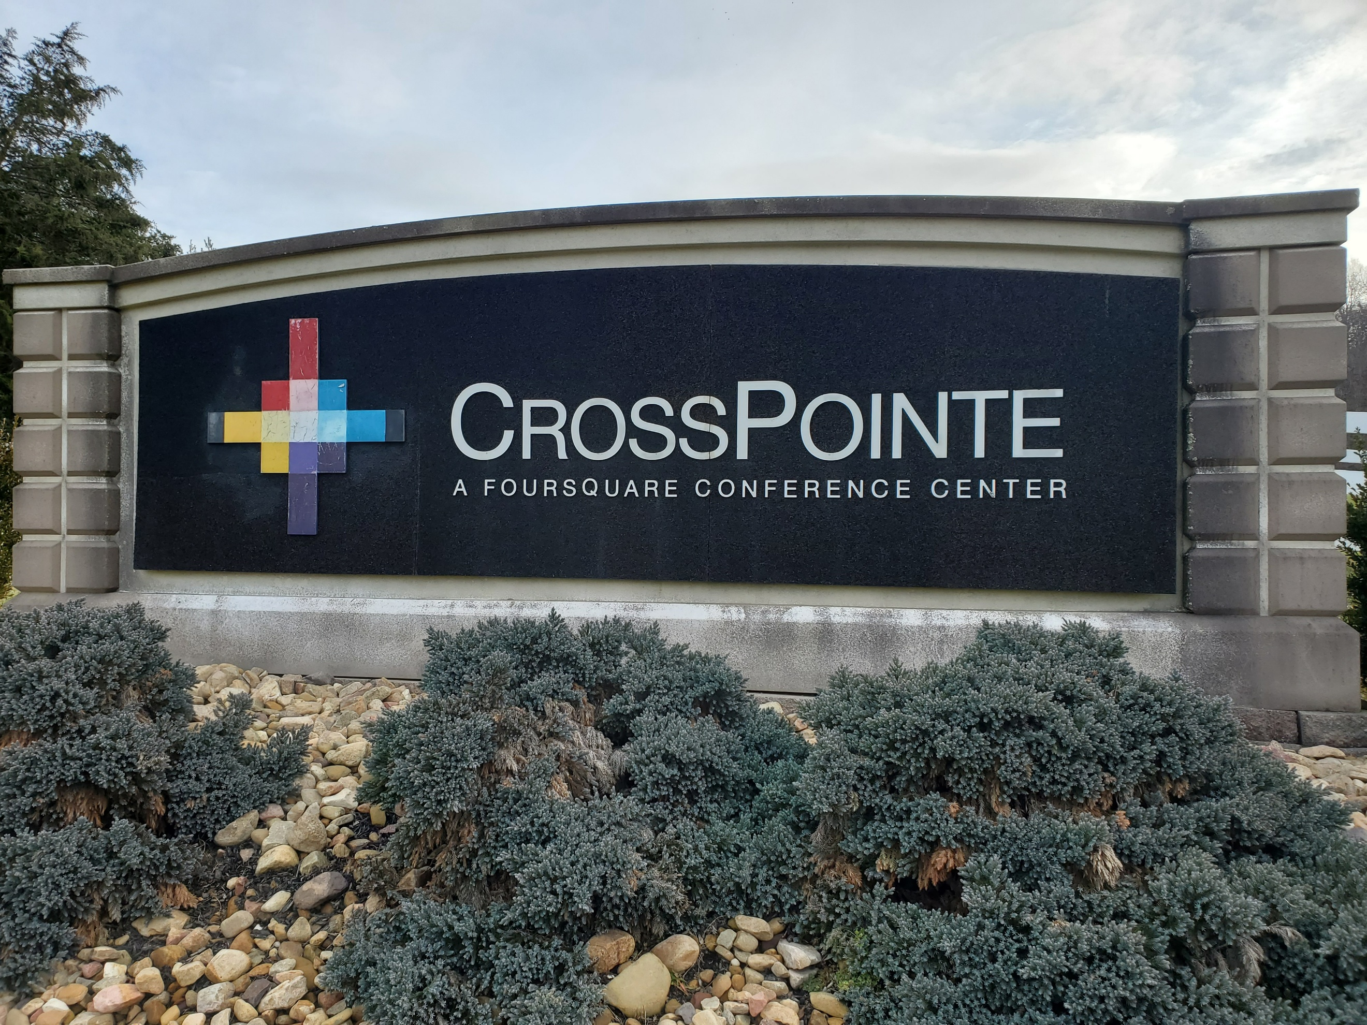
610 Peppers Ferry Road, Christiansburg Virginia 24073

Reservations: 855-530-1049
For more information and to register visit us at:
Thermalsystemtraining.com
CrossPointe Conference Center
936 Life Drive #45
Christiansburg, Virginia 24073
HVAC Water Chillers & Cooling Towers Course

Topics covered includes:
- Refrigeration and cooling basics
- Refrigeration machines
- Chiller configurations
- Chilled water system elements
- Chilled water system control and performance
- Thermal energy storage
- Chiller operation and maintenance
- Cooling tower fundamentals
- Cooling tower components
- Cooling tower configurations and applications
- Cooling tower controls
- Condenser water treatment
- Special tower considerations
- Cooling tower operation and maintenance
- Cooling tower performance testing

Light breakfast, beverages, and lunch will be provided daily.
Nearby Lodging includes:
Holiday Inn, Christiansburg 540-381-8100
Hampton Inn, Christiansburg 540-381-5874
SureStay Hotel, Christiansburg 540-381-0500

For more information and to register visit us at:
Thermalsystemtraining.com

www.thermalsystemtraining.com
T
S
T
Thermal
System Training LLC

