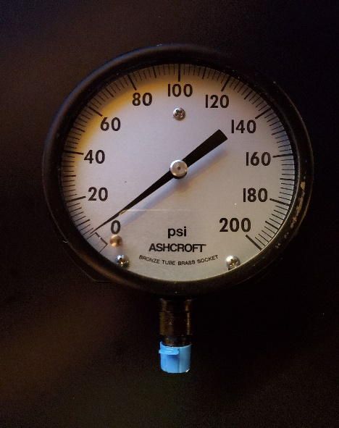
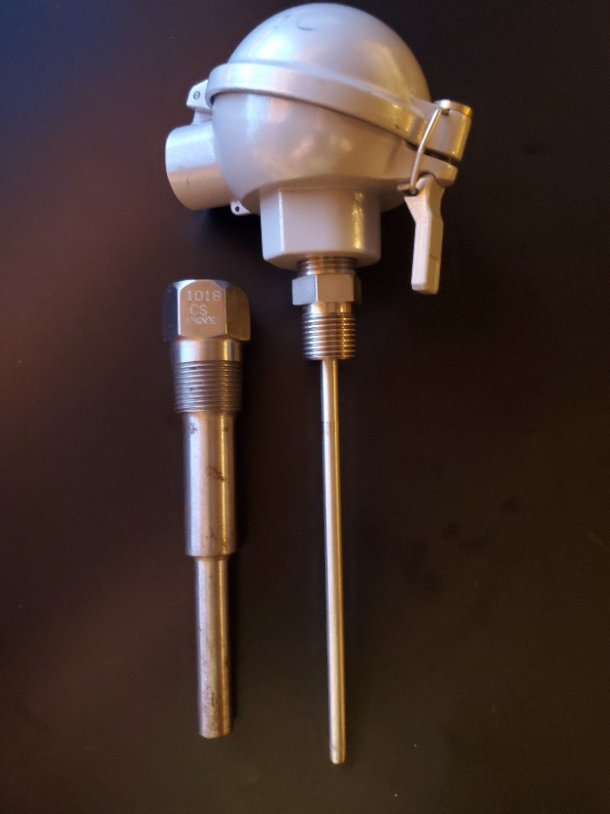
Presented By: Thermal System Training, LLC
Course Dates: April 27 – May 1, 2026 / 8:00 AM – 4:00 PM
Cost $ 2,450 per person
* New Class Location is in Christiansburg Virginia at:
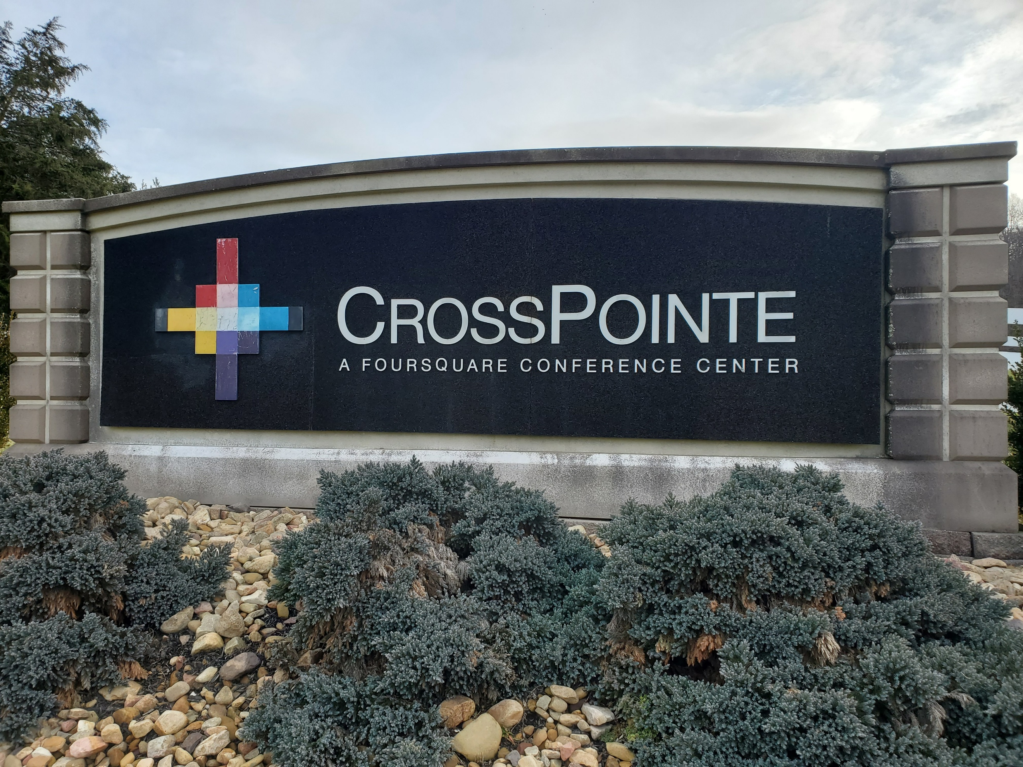
610 Peppers Ferry Road, Christiansburg Virginia 24073

Reservations: 855-530-1049
For more information and to register visit us at:
Thermalsystemtraining.com
CrossPointe Conference Center
936 Life Drive #45
Christiansburg, Virginia 24073
Focus on Pressure and Temperature Instruments. Topics covered includes:
- Modern process control systems
- Control loops and strategies
- P & ID diagrams
- Temperature scales and measurement devices
- Heat transfer and units
- Specific heat and capacity
- Thermal expansion
- Thermocouples and RTD’s
- Thermistors and IR sensors
- Temperature time constants
- Pressure, head, and hydrostatic principles
- Pressure scales and units
- Manometers
- Types of pressure sensors
- Pressure transducers
- Pressure sensor calibration
Instrumentation and Process Control One Course

Light breakfast, beverages, and lunch will be provided daily.
Nearby Lodging includes:
Holiday Inn, Christiansburg 540-381-8100
Hampton Inn, Christiansburg 540-381-5874
SureStay Hotel, Christiansburg 540-381-0500

For more information and to register visit us at:
Thermalsystemtraining.com

www.thermalsystemtraining.com
T
S
T
Thermal
System Training LLC

