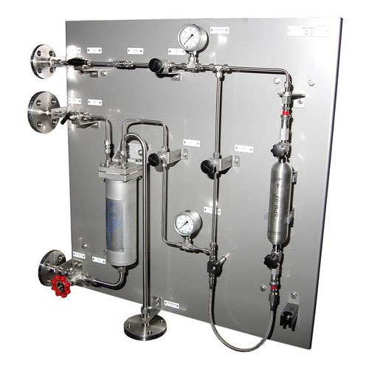
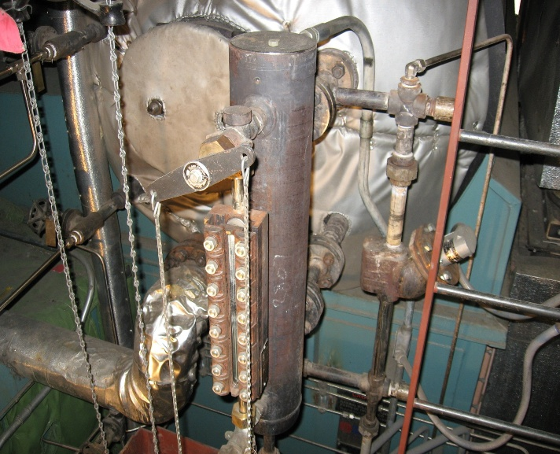
Presented By: Thermal System Training, LLC
Course Dates: May 4 – 8, 2026 / 8:00 AM – 4:00 PM
Cost $ 2,450 per person
* New Class Location is in Christiansburg Virginia at:
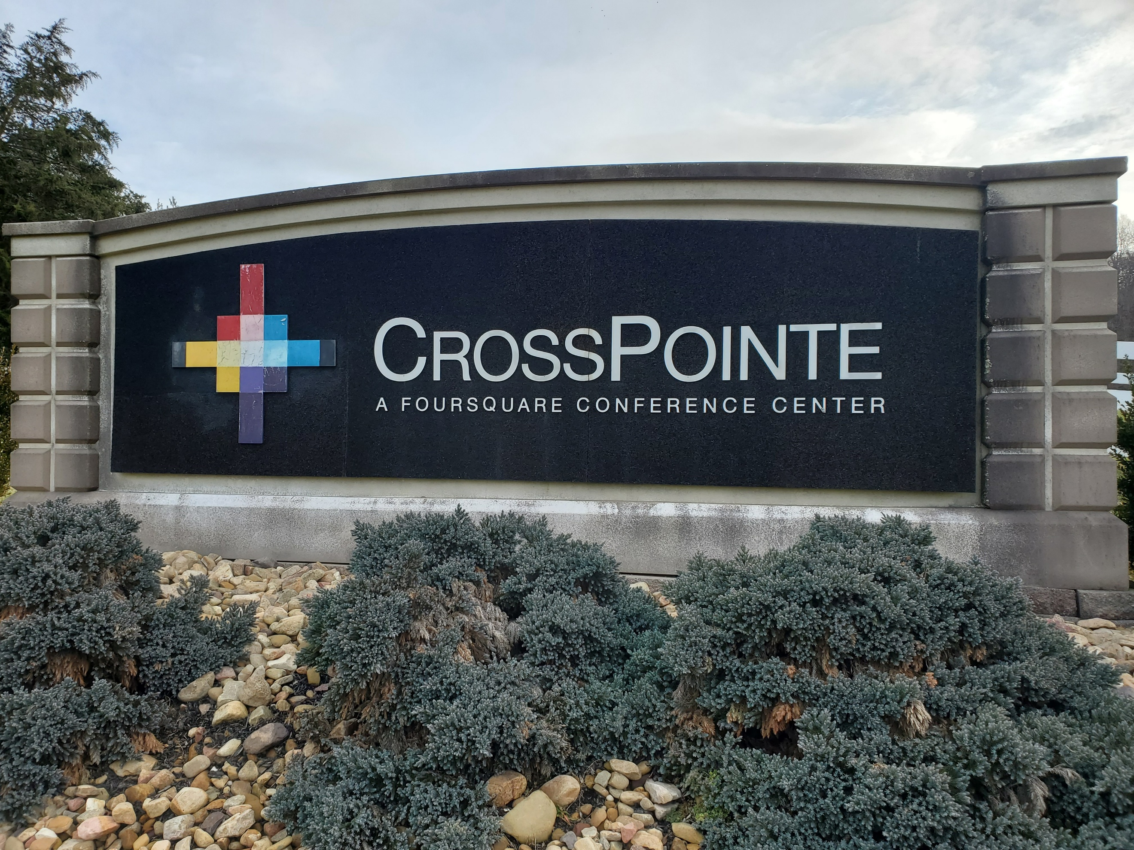
610 Peppers Ferry Road, Christiansburg Virginia 24073

Reservations: 855-530-1049
For more information and to register visit us at:
Thermalsystemtraining.com
CrossPointe Conference Center
936 Life Drive #45
Christiansburg, Virginia 24073
Focus on Level, Flow, and Analytical Instruments. Topics covered includes:
- Mechanical level instruments
- Electrical level instruments
- Ultrasonic, Radar, and Laser level instruments
- Nuclear and weight level systems
- Practical level measurement and calibration
- Fluid flow basics
- Differential pressure flowmeters
- Mechanical flowmeters
- Magnetic, ultrasonic, and mass flowmeters
- Practical flow measurement
- Gas Analyzers
- Humidity and solids moisture analyzers
- Liquid analyzers
- Electrochemical and composition analyzers
- Mechanical and proximity switches
- Practical position measurement
Instrumentation and Process Control Two Course

Light breakfast, beverages, and lunch will be provided daily.
Nearby Lodging includes:
Holiday Inn, Christiansburg 540-381-8100
Hampton Inn, Christiansburg 540-381-5874
SureStay Hotel, Christiansburg 540-381-0500

For more information and to register visit us at:
Thermalsystemtraining.com

www.thermalsystemtraining.com
T
S
T
Thermal
System Training LLC

