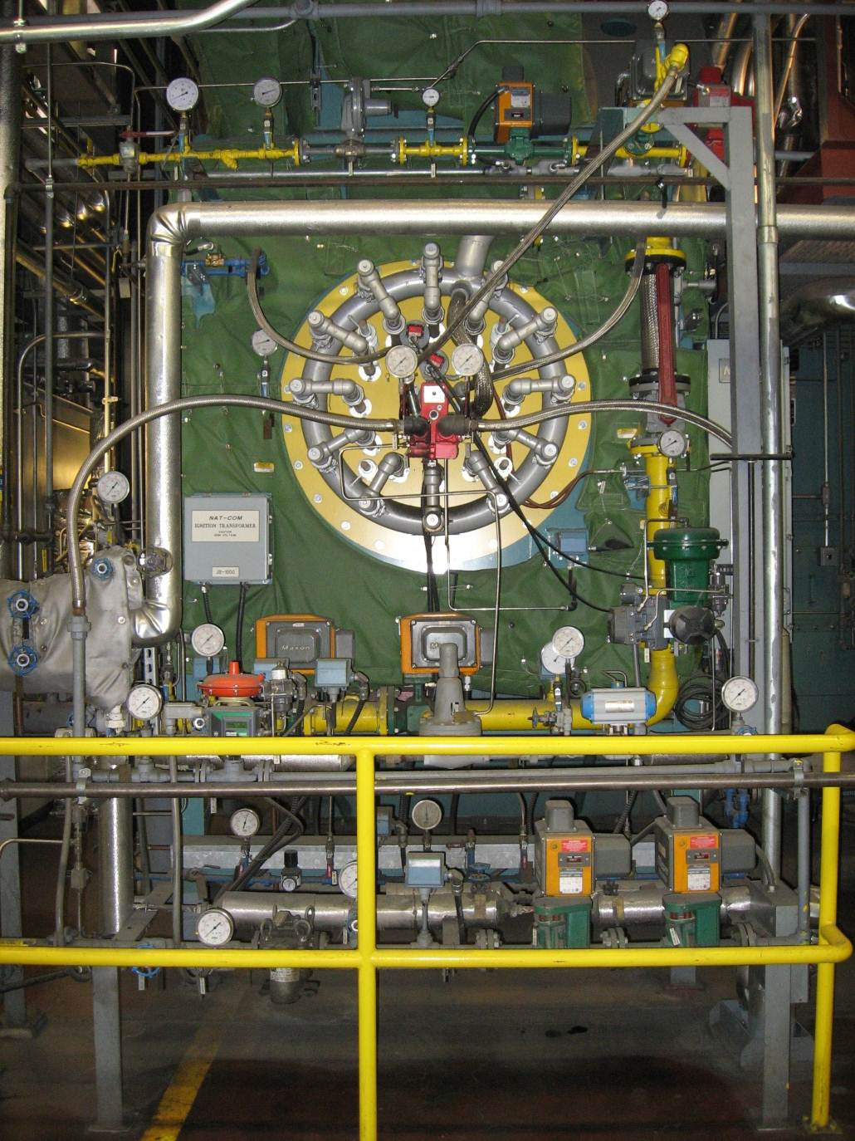
Presented By: Thermal System Training, LLC
Course Dates: August 17 – 21, 2026 / 8:00 AM – 4:00 PM
Cost $ 2,250 per person
* New Class Location is in Christiansburg Virginia at:
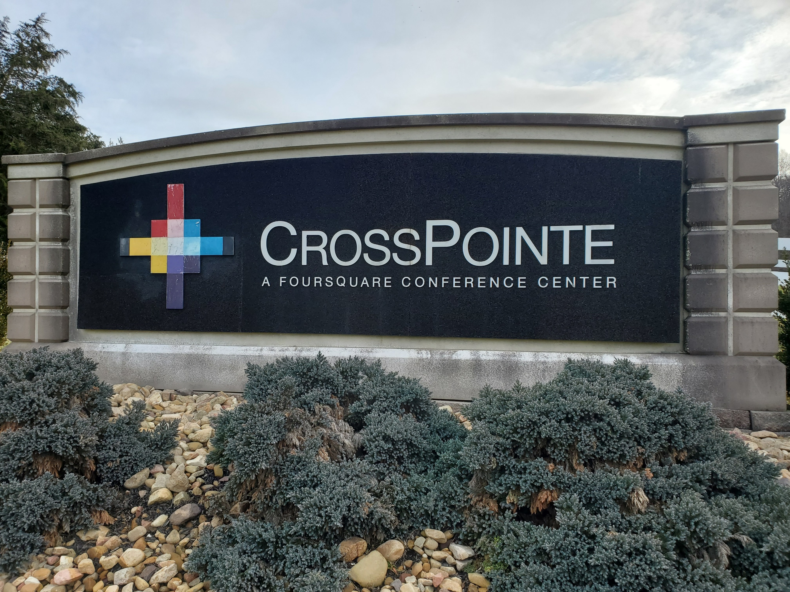
610 Peppers Ferry Road, Christiansburg Virginia 24073

Reservations: 855-530-1049
For more information and to register visit us at:
Thermalsystemtraining.com
CrossPointe Conference Center
936 Life Drive #45
Christiansburg, Virginia 24073
Light breakfast, beverages, and lunch will be provided daily.
For more information and to register visit us at:
Thermalsystemtraining.com

Nearby Lodging Includes:
Holiday Inn, Christiansburg 540-381-8100
Hampton Inn, Christiansburg 540-381-5874
SureStay Hotel, Christiansburg 540-381-0500

Topics covered includes:
- Boiler theory and principles
- Boiler construction and design
- Steam systems and controls
- Water supply systems and controls
- Water treatment systems and controls
- Fuel systems and controls
- Draft and flue gas systems and controls
- Instrumentation and control systems
www.thermalsystemtraining.com
Intermediate Boiler Operator Training & Certification

T
S
T
Thermal
System Training LLC

